CIPC XBRL Taxonomy 2023
Framework architecture document

Status: Final
Version: 1.1
Authors: Business Reporting – Advisory Group
Date: 2023-09-20

Index
Introduction 3
CIPC relation to XBRL SA Standard 4
CIPC XBRL Taxonomy Architecture 5
Scope of the framework 5
Data model 5
Location and modularization in folder and files 5
Location 5
Physical modularisation of the CIPC XBRL Taxonomy 6
Definition of concepts, dimensional constructs and other 14
Namespaces 14
Concepts and constructs 14
Roles used on extended links 17
Sets of relations 18
Labels 20
References 20
Application of dimensions 21
Default members of dimensions 21
Solo/consolidated 21
Components of budget and actual amounts 22
Typed dimensions 22
Validation rules 22
Relation to other taxonomies 25
Versioning 25
Taxonomy Package 25
Enquiries 26
Appendix A: List of business rules and compliance checks 27
A.1. List of logical rules applicable for the CA_FAS 27
A.2. Minimum Tagging Requirements applicable for the CA_FAS 27
A.3. List of logical rules selectively applicable for the IFRS, CO-OP and GRAP modules 28
A.4. Minimum Tagging Requirements selectively applicable for the IFRS, CO-OP and GRAP 30

Introduction
The purpose of this document is to present and explain the architecture of the framework of XBRL taxonomies created by the Companies and Intellectual Property Commission. This document is aimed at users of the CIPC XBRL taxonomy, in particular business users working with the taxonomy in order to produce instance documents (by applying mappings to internal systems or assigning XBRL tags with values in any other manner) as well as developers of IT solutions facilitating reporting in the XBRL format or analysis of XBRL data.
XBRL South Africa Standard and Governance Framework
The XBRL SA jurisdiction issued, on the 5th of February 2014, a request for proposals to develop the overarching XBRL SA Standard, understood as set of architectural rules and principles governing adoption and development of XBRL taxonomies in South Africa. The XBRL SA jurisdiction conducted relevant analysis and recommended future architecture for South Africa taxonomies, together with governance and maintenance procedures and requirements for XBRL software platforms, applicable for centralised processing of XBRL data. The XBRL SA project was concluded, on the 1st of May 2015, with a release of XBRL SA Standard Architecture (with supporting documents) that outlines the relevant rules and principles of development of future XBRL SA taxonomies.
Variety of data scopes that were considered in the process of development the XBRL SA Standard made XBRL SA not to follow a single modelling approach or taxonomy architecture. Identified data components corresponded to particular regulations and reporting standards that are already reflected by existing taxonomies (recognized globally by supervisory institutions throughout the world) and ready to be reused for the specific purposes of South African regulators. Therefore, the decision was to combine two international approaches: Interoperable Taxonomy Architecture (recognized as MD – Moderately Dimensional) and European Taxonomy Architecture (recognized as HD – Highly Dimensional).
The XBRL SA highlighted that ITA is to be used as a prevailing architecture for the collection of data and syntactical expression of business requirements from underlying data models described using Data Point Methodology as part of harmonised definitions across feasible domains of information. The XBRL SA standard also incorporates the use of ETA technical approach for the specific parts of XBRL SA taxonomy.
In order to combine the MD and HD models into a single taxonomy set, a specific folder structure was created to represent the physical modularization allowing the organisations to maintain the individual extended reporting scope while reusing common definitions. The structure defines two main layers for the taxonomy sets, including:
- Definition layer used for all common-core and common-industry definitions for various domains;
- Reports layer for all domain-specific or organization specific definitions and for all presentation and form-view rendering components.
Each set of files defined under the above layers should follow specific sub-folder structure depending on the approach taken. In case of data scopes identified as Moderately Dimensional it should follow the structure of IFRS Taxonomy (ITA), or for Highly Dimensional – DPM structure, recognized as European Taxonomy Architecture.
Below diagram presents the high-level physical modularization of the XBRL SA Taxonomy Set:
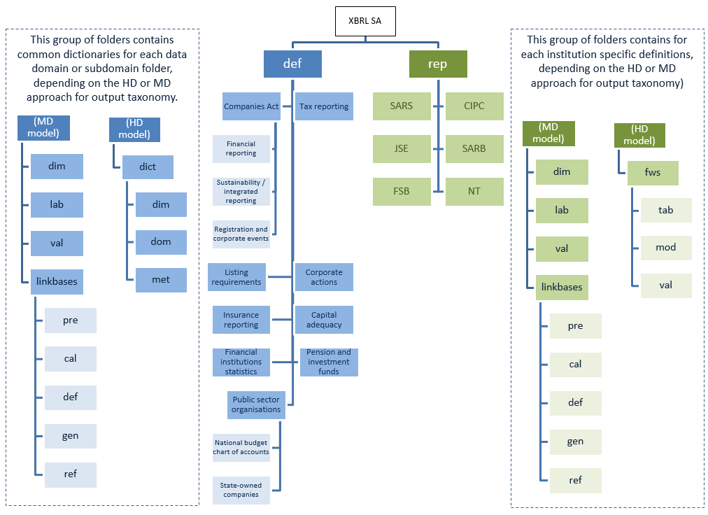
Figure 1: High-level physical modularization of the XBRL SA Taxonomy Set
For detailed information regarding the technical requirements for the XBRL SA Taxonomy Architecture, please refer to the XBRL South Africa Standard and Governance Framework and supporting documents.

CIPC relation to XBRL SA Standard
The Companies and Intellectual Property Commission was involved in the process of preparation of the XBRL South Africa Standard and was recognized as one of the major stakeholders to be taken in consideration while development of XBRL SA Taxonomy Architecture. From May 14th till 16th 2014 the XBRL SA Jurisdiction held a number of roundtable meetings with group of relevant regulatory and supervisory bodies in South Africa at the Financial Services Board in Pretoria. A set of data components was assigned to the CIPC as part of their reporting requirements, including Companies Act and Financial Reporting according to the International Financial Reporting Standards. Following international best practices and XBRL SA discoveries, the above mentioned components were agreed to be using the ITA modelling and taxonomy architecture.

CIPC XBRL Taxonomy Architecture
This section presents and explains the details of the technical architecture of the CIPC XBRL Taxonomy 2023. In particular, it explains the scope (coverage of information requirements), modularization in files, manner of defining concepts and relations and other important design aspects.

Scope of the framework
The CIPC XBRL taxonomy framework reflects information requirements for annual return filings submitted by the domestic companies in South Africa. Under the current version, the scope of the framework is limited to requirements of Companies Act, No. 71 of 2008.

Data model
Prior to the development of an XBRL taxonomy, the underlying information requirements should be analysed in order to identify reportable concepts and relations between them. This is normally prepared in a form of a data model.
Data model for the CIPC taxonomy 2023 was created as a result of analysis of the following materials:
- Companies Act, No. 71 of 2008, specifically sections 29, 30, 33, 56 and 80;
- IFRS taxonomy 2023 as published by the IASB on 23 March 2023;
- CIPC forms CoR 30.1, CoR 30.2;
- Broad-Based Black Economic Empowerment Act;
- CIPC B-BBEE Sworn Affidavit templates;
- KING IV Report on Corporate Governance;
- FRSC’s Financial Reporting Pronouncements [FRPs];
- Generally Recognized Accounting Practice [GRAP];
- Co-operatives Act;
- Public Finance Management Act; and
- Municipal Finance Management Act.
All the above mentioned information requirements are represented, to the extent needed, in Microsoft Excel format. Due to slight differences between the CO-OP, GRAP and IFRS requirements, as well as some level of reusability of elements, the 2023 data model was split into three separate workbooks, designed in a fashion that allows specifying the general characteristics of each concept, in particular the English labels, the period and data types, the purpose of each item and its placement in relation to other concepts.
The structure of each draft data model was divided into three main sections:
- Concepts tab containing all elements that are defined in the taxonomy and that are specific to the CIPC requirements [shared between CO-OP, GRAP and IFRS models];
- Enum tab that contains structures for all drop down lists applicable to the CIPC XBRL Taxonomy element [shared between CO-OP, GRAP and IFRS models]; and
- A set of other tabs that contain all hierarchies and structures used in order to arrange the information scope to be part of the CIPC taxonomy [separate structures for CO-OP, GRAP and IFRS models].

Location and modularization in folder and files

Location
The official root location for the files in the framework will be https://xbrl.cipc.co.za/taxonomy/. This domain is under control of the authority publishing the taxonomy which is the Companies and Intellectual Property Commission.
Components of the framework will be placed in folders under the root URL followed by the date of publication according to the pattern: {root URL}/{date of publication in format YYYY-MM-DD}/{abbreviated name of a component of the framework}/{file name}.

Physical modularisation of the CIPC XBRL Taxonomy
The CIPC XBRL Standard consists of sets of taxonomy files divided into:
- Definition layer (def) reflecting representations (structures and definitions) of the regulations of certain acts or additional reporting requirements;
- Reports layer (rep) reflecting representations of submission reports that are specific to CIPC.
Concerning different taxonomy architectures recognized by the XBRL SA Standard, CIPC XBRL Taxonomy is following the moderately dimensional model (MD model) reflecting Interoperable Taxonomy Architecture (ITA) and IFRS Taxonomy Architecture.
Following diagram presents the high-level physical modularization of the CIPC XBRL Taxonomy based on the folder structure of the XBRL SA Taxonomy Set.
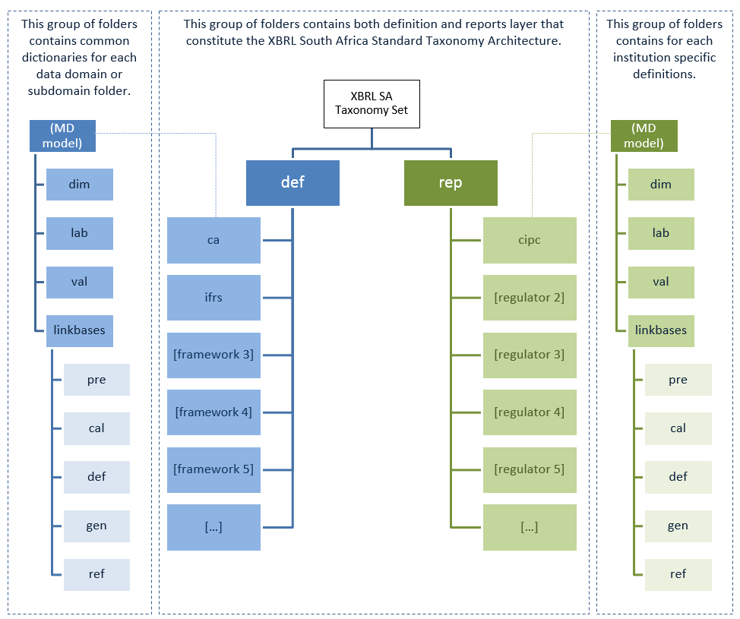
Figure 2: High-level physical modularization of the CIPC XBRL Taxonomy

Definition layer
All existing legal acts and other reporting requirements that are part of the CIPC XBRL Taxonomy scope, are defined within def folder as common dictionaries reusable by different regulators. Each subfolder reflects the contents of particular regulation using the following structure:
- root folder containing core XBRL schema with definition of business concepts and their properties:
- dimensions folder with the definition of dimensional constructs;
- labels folder with the definition of human readable labels in English;
- formulas folder with the definition of business rules (if defined) expressed using Formula 1.0 syntax;
- linkbases with the definition of relations between concepts defined in core schema (presentation, calculation and definition);
- references with the definition of references to the regulations and legal acts; and
- enumerations with the definition of drop down elements and their structures (as described later in this document); and
- fdn with the definition of all custom-defined technical constructs that are not covered explicitly by the official XBRL specifications.
At the moment not all of the above mentioned folders is used in the published version of the CIPC XBRL Taxonomy. Purpose of those is to facilitate the harmonised metadata repository in the future.

Reports layer
Reports layer is dedicated to the CIPC specific definitions of XBRL constructs (currently none are defined) and relations that are not part of common dictionary, and should reflect CIPC submission forms, with content following below structure:
- root folder containing core XBRL schema with definition of business concepts and their properties that are specific to CIPC, as well as entry points to allow the user of the taxonomy to view selected reporting scope:
- dimensions folder with the definition and hierarchies of dimensional constructs;
- labels folder with the definition of human readable labels in English specifically created by the CIPC;
- entry folder with the different combination of entry points used for reporting purposes (i.e. referenced from instance documents filed by reporting entities);
- formula folder with the definition of business rules (if defined) expressed using Formula 1.0 syntax;
- linkbases with the definition of relations between concepts defined in core schema (presentation, calculation, definition, generic and reference);
- references with the definition of references to the regulations and legal acts; and
- enumerations with the definition of drop down elements and their structures (as described later in this document);
Full entry points used for technical purposes are defined in in the root folder within the reports layer. They allow classifying submitted reports in terms of main information scope.
Entry points used for reporting purposes are stored in the entry folder. Name of these entry point files start with the regulator name followed by an ordering component, abbreviated contents of the entry point and a publication date in format YYYY-MM-DD, according to the below pattern:
{regulator name}_{ordering component}_{content}_entry_point_{date stamp in format YYYY-MM-DD}.xsd
The current version of the taxonomy allows selecting between sixteen various reporting entry point schema files for each IFRS and IFRS for SMEs module, 32 entry point schema files for Co-operatives and additional two entry points for the GRAP module. Moreover, for each module there is a full technical entry point that gathers all the hierarchies present in the taxonomy for a given information scope. It is not recommended to use the technical entry points for reporting purposes as it may result in additional calculation warnings. The following figure presents the list of available entry points in the CIPC XBRL taxonomy and their components:
Entry point | Annual returns | Financial accountability supplement | Annual statistical information | General Information | Statement of financial position | Income statement | Other comprehensive income | Cash flows | Changes in equity | Changes in net assets | Income and retained earnings | Notes | Disclosures
full_cipc_entry_point_ca_fas-2023-09-30 | n/a | x | n/a | n/a | n/a | n/a | n/a | n/a | n/a | n/a | n/a | n/a | n/a
full_cipc_entry_point_coops_a1_2023-04-01.xsd | x | n/a | x | x | all | all | all | n/a | n/a | n/a | n/a | n/a | n/a
full_cipc_entry_point_full_ifrs_2023-09-30 | x | n/a | x | x | all | all | all | all | x | x | n/a | all | all
full_cipc_entry_point_full_ifrs_coops_a2_b_c_others_2023-04-01.xsd | x | n/a | x | x | all | all | all | all | x | x | n/a | all | all
full_cipc_entry_point_grap_2023-09-30 | x | n/a | n/a | x | current / non-current | all | n/a | direct | n/a | x | n/a | all | all
full_cipc_entry_point_ifrs_for_smes_2023-09-30 | x | n/a | x | x | all | all | all | all | x | n/a | x | all | all
full_cipc_entry_point_ifrs_for_smes_coops_a2_b_c_others_2023-04-01.xsd | x | n/a | x | x | all | all | all | all | x | n/a | x | all | all
cipc_full_ifrs_01_isbn_sfpcn_ocibt_cfim_entry_point_2023-09-30 | x | n/a | x | x | current / non-current | by nature | before tax | indirect | x | x | n/a | all | all
cipc_full_ifrs_02_isbn_sfpcn_ocint_cfim_entry_point_2023-09-30 | x | n/a | x | x |  |  | net of tax |  | x | x | n/a | all | all
cipc_full_ifrs_03_isbf_sfpcn_ocibt_cfim_entry_point_2023-09-30 | x | n/a | x | x |  | by function | before tax |  | x | x | n/a | all | all
cipc_full_ifrs_04_isbf_sfpcn_ocint_cfim_entry_point_2023-09-30 | x | n/a | x | x |  |  | net of tax |  | x | x | n/a | all | all
cipc_full_ifrs_05_isbn_sfpol_ocibt_cfim_entry_point_2023-09-30 | x | n/a | x | x | order of liquidity | by nature | before tax |  | x | x | n/a | all | all
cipc_full_ifrs_06_isbn_sfpol_ocint_cfim_entry_point_2023-09-30 | x | n/a | x | x |  |  | net of tax |  | x | x | n/a | all | all
cipc_full_ifrs_07_isbf_sfpol_ocibt_cfim_entry_point_2023-09-30 | x | n/a | x | x |  | by function | before tax |  | x | x | n/a | all | all
cipc_full_ifrs_08_isbf_sfpol_ocint_cfim_entry_point_2023-09-30 | x | n/a | x | x |  |  | net of tax |  | x | x | n/a | all | all
cipc_full_ifrs_09_isbn_sfpcn_ocibt_cfdm_entry_point_2023-09-30 | x | n/a | x | x | current / non-current | by nature | before tax | direct | x | x | n/a | all | all
cipc_full_ifrs_10_isbn_sfpcn_ocint_cfdm_entry_point_2023-09-30 | x | n/a | x | x |  |  | net of tax |  | x | x | n/a | all | all
cipc_full_ifrs_11_isbf_sfpcn_ocibt_cfdm_entry_point_2023-09-30 | x | n/a | x | x |  | by function | before tax |  | x | x | n/a | all | all
cipc_full_ifrs_12_isbf_sfpcn_ocint_cfdm_entry_point_2023-09-30 | x | n/a | x | x |  |  | net of tax |  | x | x | n/a | all | all
cipc_full_ifrs_13_isbn_sfpol_ocibt_cfdm_entry_point_2023-09-30 | x | n/a | x | x | order of liquidity | by nature | before tax |  | x | x | n/a | all | all
cipc_full_ifrs_14_isbn_sfpol_ocint_cfdm_entry_point_2023-09-30 | x | n/a | x | x |  |  | net of tax |  | x | x | n/a | all | all
cipc_full_ifrs_15_isbf_sfpol_ocibt_cfdm_entry_point_2023-09-30 | x | n/a | x | x |  | by function | before tax |  | x | x | n/a | all | all
cipc_full_ifrs_16_isbf_sfpol_ocint_cfim_entry_point_2023-09-30 | x | n/a | x | x |  |  | net of tax |  | x | x | n/a | all | all
cipc_ifrs_for_smes_01_isbn_sfpcn_ocibt_cfim_entry_point_2023-09-30 | x | n/a | x | x | current / non-current | by nature | before tax | indirect | x | n/a | x | all | all
cipc_ifrs_for_smes_02_isbn_sfpcn_ocint_cfim_entry_point_2023-09-30 | x | n/a | x | x |  |  | net of tax |  | x | n/a | x | all | all
cipc_ifrs_for_smes_03_isbf_sfpcn_ocibt_cfim_entry_point_2023-09-30 | x | n/a | x | x |  | by function | before tax |  | x | n/a | x | all | all
cipc_ifrs_for_smes_04_isbf_sfpcn_ocint_cfim_entry_point_2023-09-30 | x | n/a | x | x |  |  | net of tax |  | x | n/a | x | all | all
cipc_ifrs_for_smes_05_isbn_sfpol_ocibt_cfim_entry_point_2023-09-30 | x | n/a | x | x | order of liquidity | by nature | before tax |  | x | n/a | x | all | all
cipc_ifrs_for_smes_06_isbn_sfpol_ocint_cfim_entry_point_2023-09-30 | x | n/a | x | x |  |  | net of tax |  | x | n/a | x | all | all
cipc_ifrs_for_smes_07_isbf_sfpol_ocibt_cfim_entry_point_2023-09-30 | x | n/a | x | x |  | by function | before tax |  | x | n/a | x | all | all
cipc_ifrs_for_smes_08_isbf_sfpol_ocint_cfim_entry_point_2023-09-30 | x | n/a | x | x |  |  | net of tax |  | x | n/a | x | all | all
cipc_ifrs_for_smes_09_isbn_sfpcn_ocibt_cfdm_entry_point_2023-09-30 | x | n/a | x | x | current / non-current | by nature | before tax | direct | x | n/a | x | all | all
cipc_ifrs_for_smes_10_isbn_sfpcn_ocint_cfdm_entry_point_2023-09-30 | x | n/a | x | x |  |  | net of tax |  | x | n/a | x | all | all
cipc_ifrs_for_smes_11_isbf_sfpcn_ocibt_cfdm_entry_point_2023-09-30 | x | n/a | x | x |  | by function | before tax |  | x | n/a | x | all | all
cipc_ifrs_for_smes_12_isbf_sfpcn_ocint_cfdm_entry_point_2023-09-30 | x | n/a | x | x |  |  | net of tax |  | x | n/a | x | all | all
cipc_ifrs_for_smes_13_isbn_sfpol_ocibt_cfdm_entry_point_2023-09-30 | x | n/a | x | x | order of liquidity | by nature | before tax |  | x | n/a | x | all | all
cipc_ifrs_for_smes_14_isbn_sfpol_ocint_cfdm_entry_point_2023-09-30 | x | n/a | x | x |  |  | net of tax |  | x | n/a | x | all | all
cipc_ifrs_for_smes_15_isbf_sfpol_ocibt_cfdm_entry_point_2023-09-30 | x | n/a | x | x |  | by function | before tax |  | x | n/a | x | all | all
cipc_ifrs_for_smes_16_isbf_sfpol_ocint_cfim_entry_point_2023-09-30 | x | n/a | x | x |  |  | net of tax |  | x | n/a | x | all | all
cipc_grap_01_isbf_sfpcn_cfdm_entry_point_2023-09-30 | x | n/a | n/a | x | current / non-current | by function | n/a | direct | n/a | x | n/a | all | all
cipc_grap_02_isbn_sfpcn_cfdm_entry_point_2023-09-30 | x | n/a | n/a | x | current / non-current | by nature | n/a | direct | n/a | x | n/a | all | all
cipc_full_ifrs_coop_coop_01_isbn_sfpcn_ocibt_cfim_entry_point_2023-09-30 | x | n/a | x | x | current / non-current | by nature | before tax | indirect | x | x | n/a | all | all
cipc_full_ifrs_coop_coop_02_isbn_sfpcn_ocint_cfim_entry_point_2023-09-30 | x | n/a | x | x |  |  | net of tax |  | x | x | n/a | all | all
cipc_full_ifrs_coop_coop_03_isbf_sfpcn_ocibt_cfim_entry_point_2023-09-30 | x | n/a | x | x |  | by function | before tax |  | x | x | n/a | all | all
cipc_full_ifrs_coop_coop_04_isbf_sfpcn_ocint_cfim_entry_point_2023-09-30 | x | n/a | x | x |  |  | net of tax |  | x | x | n/a | all | all
cipc_full_ifrs_coop_coop_05_isbn_sfpol_ocibt_cfim_entry_point_2023-09-30 | x | n/a | x | x | order of liquidity | by nature | before tax |  | x | x | n/a | all | all
cipc_full_ifrs_coop_coop_06_isbn_sfpol_ocint_cfim_entry_point_2023-09-30 | x | n/a | x | x |  |  | net of tax |  | x | x | n/a | all | all
cipc_full_ifrs_coop_coop_07_isbf_sfpol_ocibt_cfim_entry_point_2023-09-30 | x | n/a | x | x |  | by function | before tax |  | x | x | n/a | all | all
cipc_full_ifrs_coop_coop_08_isbf_sfpol_ocint_cfim_entry_point_2023-09-30 | x | n/a | x | x |  |  | net of tax |  | x | x | n/a | all | all
cipc_full_ifrs_coop_coop_09_isbn_sfpcn_ocibt_cfdm_entry_point_2023-09-30 | x | n/a | x | x | current / non-current | by nature | before tax | direct | x | x | n/a | all | all
cipc_full_ifrs_coop_coop_10_isbn_sfpcn_ocint_cfdm_entry_point_2023-09-30 | x | n/a | x | x |  |  | net of tax |  | x | x | n/a | all | all
cipc_full_ifrs_coop_coop_11_isbf_sfpcn_ocibt_cfdm_entry_point_2023-09-30 | x | n/a | x | x |  | by function | before tax |  | x | x | n/a | all | all
cipc_full_ifrs_coop_coop_12_isbf_sfpcn_ocint_cfdm_entry_point_2023-09-30 | x | n/a | x | x |  |  | net of tax |  | x | x | n/a | all | all
cipc_full_ifrs_coop_coop_13_isbn_sfpol_ocibt_cfdm_entry_point_2023-09-30 | x | n/a | x | x | order of liquidity | by nature | before tax |  | x | x | n/a | all | all
cipc_full_ifrs_coop_coop_14_isbn_sfpol_ocint_cfdm_entry_point_2023-09-30 | x | n/a | x | x |  |  | net of tax |  | x | x | n/a | all | all
cipc_full_ifrs_coop_coop_15_isbf_sfpol_ocibt_cfdm_entry_point_2023-09-30 | x | n/a | x | x |  | by function | before tax |  | x | x | n/a | all | all
cipc_full_ifrs_coop_coop_16_isbf_sfpol_ocint_cfim_entry_point_2023-09-30 | x | n/a | x | x |  |  | net of tax |  | x | x | n/a | all | all
cipc_ifrs_for_smes_coop_01_isbn_sfpcn_ocibt_cfim_entry_point_2023-09-30 | x | n/a | x | x | current / non-current | by nature | before tax | indirect | x | n/a | x | all | all
cipc_ifrs_for_smes_coop_02_isbn_sfpcn_ocint_cfim_entry_point_2023-09-30 | x | n/a | x | x |  |  | net of tax |  | x | n/a | x | all | all
cipc_ifrs_for_smes_coop_03_isbf_sfpcn_ocibt_cfim_entry_point_2023-09-30 | x | n/a | x | x |  | by function | before tax |  | x | n/a | x | all | all
cipc_ifrs_for_smes_coop_04_isbf_sfpcn_ocint_cfim_entry_point_2023-09-30 | x | n/a | x | x |  |  | net of tax |  | x | n/a | x | all | all
cipc_ifrs_for_smes_coop_05_isbn_sfpol_ocibt_cfim_entry_point_2023-09-30 | x | n/a | x | x | order of liquidity | by nature | before tax |  | x | n/a | x | all | all
cipc_ifrs_for_smes_coop_06_isbn_sfpol_ocint_cfim_entry_point_2023-09-30 | x | n/a | x | x |  |  | net of tax |  | x | n/a | x | all | all
cipc_ifrs_for_smes_coop_07_isbf_sfpol_ocibt_cfim_entry_point_2023-09-30 | x | n/a | x | x |  | by function | before tax |  | x | n/a | x | all | all
cipc_ifrs_for_smes_coop_08_isbf_sfpol_ocint_cfim_entry_point_2023-09-30 | x | n/a | x | x |  |  | net of tax |  | x | n/a | x | all | all
cipc_ifrs_for_smes_coop_09_isbn_sfpcn_ocibt_cfdm_entry_point_2023-09-30 | x | n/a | x | x | current / non-current | by nature | before tax | direct | x | n/a | x | all | all
cipc_ifrs_for_smes_coop_10_isbn_sfpcn_ocint_cfdm_entry_point_2023-09-30 | x | n/a | x | x |  |  | net of tax |  | x | n/a | x | all | all
cipc_ifrs_for_smes_coop_11_isbf_sfpcn_ocibt_cfdm_entry_point_2023-09-30 | x | n/a | x | x |  | by function | before tax |  | x | n/a | x | all | all
cipc_ifrs_for_smes_coop_12_isbf_sfpcn_ocint_cfdm_entry_point_2023-09-30 | x | n/a | x | x |  |  | net of tax |  | x | n/a | x | all | all
cipc_ifrs_for_smes_coop_13_isbn_sfpol_ocibt_cfdm_entry_point_2023-09-30 | x | n/a | x | x | order of liquidity | by nature | before tax |  | x | n/a | x | all | all
cipc_ifrs_for_smes_coop_14_isbn_sfpol_ocint_cfdm_entry_point_2023-09-30 | x | n/a | x | x |  |  | net of tax |  | x | n/a | x | all | all
cipc_ifrs_for_smes_coop_15_isbf_sfpol_ocibt_cfdm_entry_point_2023-09-30 | x | n/a | x | x |  | by function | before tax |  | x | n/a | x | all | all
cipc_ifrs_for_smes_coop_16_isbf_sfpol_ocint_cfim_entry_point_2023-09-30 | x | n/a | x | x |  |  | net of tax |  | x | n/a | x | all | all

Definition of concepts, dimensional constructs and other
Concepts, dimensional constructs and other artefacts are defined in XBRL schema files. In particular, XBRL schema files contain definitions of:
- reportable concepts (items),
- non-reportable concepts (abstracts) used to support browsing of the taxonomy tree structures (relations),
- dimensional constructs (hypercube items, dimension items and domain members) that reflect breakdowns or special characteristics applicable for reportable concepts,
- enumeration drop down list elements,
- roleTypes used on definition extended links that combine relationships of a specific nature or application (e.g. Statement of Financial Position, Note on related parties, etc.).

Namespaces
Namespaces are used to differentiate between concepts defined by different regulations or applicable for different purposes. They are used in order to avoid name clashes and indicate the origin of each defined concept or construct.
Namespaces in CIPC Taxonomy are constructed with base part https://xbrl.cipc.co.za/taxonomy/ followed by an identification of a component of a framework (e.g. ‘ca’ for Companies Act). The list of currently used namespaces and prefixes (applied consistently across the framework) is defined below:
Prefix | Namespace
cipc_ca_fas | https://xbrl.cipc.co.za/taxonomy/ca_entry_point
cipc_full_ifrs | https://xbrl.cipc.co.za/taxonomy/full_ifrs_entry_point
cipc_full_ifrs_coops | https://xbrl.cipc.co.za/taxonomy/full_ifrs_coops_entry_point
cipc_grap | https://xbrl.cipc.co.za/taxonomy/grap_entry_point
cipc_ifrs_for_smes | https://xbrl.cipc.co.za/taxonomy/ifrs_for_smes_entry_point
cipc_ifrs_for_smes_coops | https://xbrl.cipc.co.za/taxonomy/ifrs_for_smes_coops_entry_point
cipc-coop | https://xbrl.cipc.co.za/taxonomy/coop_entry_point
cipc-ca | https://xbrl.cipc.co.za/taxonomy/ca
cipc-ca-enum | https://xbrl.cipc.co.za/taxonomy/ca/enum
cipc-fdn | https://xbrl.cipc.co.za/taxonomy/fdn
mfma | https://xbrl.cipc.co.za/taxonomy/mfma
coop | https://xbrl.cipc.co.za/taxonomy/coop
grap | https://xbrl.cipc.co.za/taxonomy/grap
pfma | https://xbrl.cipc.co.za/taxonomy/pfma
rol_cipc_enum | https://xbrl.cipc.co.za/taxonomy/role/enum
rol_cipc_full_ifrs_dim | https://xbrl.cipc.co.za/taxonomy/role/dimensions/full_ifrs
rol_cipc_grap_dim | https://xbrl.cipc.co.za/taxonomy/role/dimensions/grap
rol_cipc_ifrs_smes_dim | https://xbrl.cipc.co.za/taxonomy/role/dimensions/ifrs_for_smes
rol_ca | https://xbrl.cipc.co.za/taxonomy/role/ca
rol_coops | https://xbrl.cipc.co.za/taxonomy/role/coop
rol_grap | https://xbrl.cipc.co.za/taxonomy/role/grap
rol_ifrs_for_smes | https://xbrl.cipc.co.za/taxonomy/role/ifrs_for_smes
rol_ifrs_full | https://xbrl.xbrl.ifrs.org/taxonomy/role/full_ifrs
Table 1: Namespaces and prefixes used in CIPC XBRL Taxonomy

Concepts and constructs
As described above, the CIPC XBRL Taxonomy contains definitions of reportable concepts (items), non-reportable concepts (abstracts) and dimensional constructs (hypercubes, dimensions and domain members).
All concepts are defined in item substitution group or derived from it (hypercubeItem for hypercubes and dimensionItem for dimensions). All concepts are nillable (@nillable="true") hence, they can be reported as nilled (@xsi:nil="true"). Although semantically unimportant, values of @id attribute (used for the purpose of creating links in XLink) are constructed basing on the pattern: {recommended prefix}_{element name}.
Naming convention for CIPC XBRL Taxonomy concepts is in general following IFRS rules and principles defined in Appendix A: Style Guide.

Reportable concepts
Definition of reportable (non-abstract, i.e. @abstract="false") concept must at minimum consist of:
- unique local (within a namespace) name,
- indication of a period type,
- identification of a data type.
Names of reportable concepts are corresponding to the L3C (Label CamelCase Concatenation) representation of meaningful standard labels in English.
Value of @periodType attribute is either instant for these concepts that are reported at a point of time (as of specified date) or duration for concepts representing flows and changes (between specified dates or infinite). In cases where the period type is not obvious, the period type attribute is set to duration. This information must be taken into consideration in instance document when constructing contexts for facts based on reportable concepts. For textual concepts (i.e. concepts whose data type is stringItemType) start and end dates should reflect the boundary dates for which a report is created, for example, if the financial statement covers the third quarter of 2010 then the dates are 2010-07-01 and 2010-09-30 respectively. Similarly reasoning applies for concepts that represent dates. For instance in an annual report commencing June 2009 the context start and end dates for date concepts such as “Reporting period end date”, “Reporting period start date” and “Date of approval of report” would be 2009-07-01 and 2010-06-30 respectively.

Data types
Data type defines constraints on possible to report values. It is assumed that CIPC XBRL Taxonomy may apply any of the standard XBRL data types as well as their extensions and restriction. Currently, the CIPC XBRL taxonomy make use of the following data types for reportable concepts:
- stringItemType (base XBRL type),
- booleanItemType (base XBRL type),
- dateItemType (base XBRL type)
- monetaryItemType (base XBRL type),
- decimalItemType (base XBRL type),
- integerItemType (base XBRL type),
- domainItemType (XBRL International Registry type DTR 1.1),
- textBlockItemType (XBRL International Registry type DTR 1.1),
- enumerationItemType (Extensible Enumerations 2.0. Specification type),
- customerCodeItemType (custom item type; restriction of a stringItemType),
- identityNumberItemType (custom item type; restriction of a integerItemType),
- isoCountryCodeItemType (custom item type; restriction of a stringItemType),
- registrationNumberItemType (custom item type; restriction of a stringItemType).
All custom data types are defined in the definition layer under fdn subfolder’s schema cipc_ca_fdn_2023-09-30.xsd. Fragment of a custom data type isoCountryCodeItemType declaration is presented on the code example below:
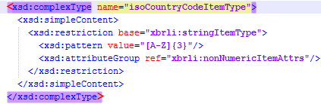
Code example 1: Declaration of the custom data in the CIPC XBRL Taxonomy
All elements that are used as to be serving as dropdown lists are defined in accordance to the Extensible Enumerations 2.0. This is in contraction to the previous taxonomy where the enumerations 1.0 specification was used. Specification within the definition layer under the folder enumerations. Those elements are using data type enum2:enumerationItemType and are described in the cipc_ca-enum_2023-09-30.xsd schema with additional attributes:
- enum:linkrole pointing to the Extended Link Role with the hierarchy defined for the enumeration options,
- enum:domain pointing to the parent domain member storing the available enumeration options,
- enum:headUsable describing the usability of the parent domain member.
Elements treated as enumeration options are defined as domain members and structured within the Definition linkbase (as described later in this document).

Abstract constructs
All non-reportable concepts have @abstract="true".
Names of abstract constructs are corresponding to the L3C (Label CamelCase Concatenation) representation of meaningful standard labels in English followed by the word Abstract (e.g. @name="IntangibleAssetsAbstract") in order not to occupy meaningful names that may be otherwise assigned to reportable concepts and differentiate from other constructs.
Although it is semantically unimportant, all abstracts should have @periodType="duration" and @dataType="stringItemType".

Dimensional constructs
Definition of dimensional constructs are following the rules of the XBRL Dimensions 1.0 specification and the recent recommendations and deliverables of the XBRL International Working Group on Interoperable Taxonomy Architecture.
According to the above, all dimensional constructs are defined as abstracts (@abstract="true"). Moreover, hypercubes should be defined in hypercubeItem and dimensions in dimensionItem substitutions groups, data type of domain members are domainItemType, and, although semantically unimportant, all dimensional constructs have @periodType="duration" and hypercubes and dimensions have @dataType="stringItemType".
Names of dimensional constructs are corresponding to the L3C (Label CamelCase Concatenation) representation of meaningful standard labels in English followed by one of the following words:
- Table for hypercube items (e.g. @name="DisclosureOfClassesOfShareCapitalTable"),
- Axis for dimension items (e.g. @name="MaturityAxis"),
- Member for domain member (e.g. @name="PlantAndMachineryMember") (except of enumeration lists),
in order not to occupy meaningful names that may be otherwise assigned to reportable concepts and differentiate from other constructs.
As a result of application of certain modelling techniques which rationales are described later in this document, the CIPC XBRL taxonomy defines a number of typed dimensions and hence also typed domains. Definition of a typed domain must consist of a @name, @dataType and @id (semantically unimportant but required in order to reference from a declaration of a typed dimensions). Names of typed domains reflect the camel-case description of their content followed by the component identifier (e.g. identityNumber). @dataType of typed domains is integer (XML Schema data type).

Roles used on extended links
XBRL schema files contain declarations of roleTypes used on extended links. They should distinguish and name the sets of relations defined in linkbase files.
Declaration of a roleType should consist of a @roleURI attribute (which is a unique identification of a role in a form a Unified Resource Identifier that allows to create networks of relations spread across many files), an @id attribute (used for linking purposes with no semantic meaning) and subelements: definition (containing human readable description in a single language) and usedOn specifying the kinds of extended links (or resources) where the declared roleType can be applied.
In general, roleTypes are created for two purposes:
- due to business reasons - in order to support browsing of a taxonomy by separating information sets (concepts and relations between them) that represent certain parts of reporting requirements (e.g. all concepts from Balances sheet account form and relations between them),
- due to technical reasons, as a consequence of rules defined in specifications (e.g. disallowing undirected cycles for certain types of relations, algorithms for inheritance of dimensional information ancestors, etc.)
Due to the reasons defined above all roleTypes defined in the CIPC XBRL Taxonomy contain a number component. It should consist of a main three-digit identifier of an information set from business perspective, followed by a three-digit identifier of a subset of relations for a given information set (e.g. 801701). This number component should be included on each roleType as part of a value of @roleURI, definition element, where main identifier precedes the subset identifier, and generic labels on roleTypes (if applied in the future). This component serves also the ordering purposes in the absence of an order identifier on extended links. Its use and construction are explained later in this section.
In terms of structuring of relationships in the definition linkbase, the CIPC XBRL Taxonomy should distinguish between the following five types of roleTypes, which are used to define:
- general information sets containing items linked to commonly applied dimensional information (e.g. distinction between solo and consolidated data),
- enumeration sets containing items structured in form of drop down lists,
- dimensional qualification of line items not linked to any hypercubes in the other hierarchies present in the taxonomy; and
- default members for all dimensions defined in the CIPC XBRL taxonomy (or referred from external taxonomies).
Description of a type of information set (regarding which group it applies to) should be expressed by the pattern applied for the number component and construction of a value of @roleURI attribute, definition element and generic labels for roleTypes.
For the general Companies Act requirements, the number component starts with three zeros followed by subset number ordering the type of particular CIPC form (e.g. [000.200] Financial Accountability Supplement).
All primary financial statements are having ordering component reflecting its IFRS representation, adjusted to the general pattern of six-digits number, to allow its future use, if necessary, for any subset of related information to be incorporated into the CIPC XBRL Taxonomy. All notes and disclosures are starting with a reserved three digit identifier with value [8XX] followed by a numbering component for the subset information.
Three digit identifier with values 9{XX} should be reserved for general domains of dimensions, except of [999] which is reserved for storing Extensible Enumeration 2.0 structures within the Definition Linkbase. Another exception is roleType identified by [999999] component, which serves the purpose of linking all line items that are not dimensionally qualified to at least one hypercube with a prescribed dimension (axis depends on the taxonomy module)
As explained above, value of definition sub elements should consist of a number component (in square brackets) followed by the human description (in English) of the content of the extended link for the purpose of which the roleType is defined (e.g. [000.100] Annual returns). If a roleType is used to express explanatory information, it contains components ‘Notes –‘ (deriving from IFRS taxonomy) or ‘Disclosures –‘ (for Companies Act requirements) at the beginning of definition description (e.g. [800.900] Disclosures – Directors’ functions and remunerations). For detailing the enumeration list dropdowns, a word Enumerations is used followed by a dash followed by an identification of the information set (e.g. [999.01] Enumerations – Recognised profession). For dimensional information deriving from the IFRS taxonomy (and defined by the CIPC XBRL Taxonomy) a word Axis followed by a dash followed by a description of the dimensional information stored (e.g. [990.000] Axis – Defaults).
Construction of @roleURIs should begin with the following base URI: https://xbrl.cipc.co.za/ taxonomy/role/{component of the framework} followed by the number component (applicable for all applicable statements, explanatory notes and disclosures and dimensional structures); or https://xbrl.cipc.co.za/ taxonomy/{component of the framework}/role followed by the number component and followed by component distinguishing type of information stored and the camel-case description in English (applicable only for enumerations) of the content of the extended link for the purpose of which the roleType is defined.
roleTypes defined by in the CIPC XBRL Taxonomy can be used on presentationLink, definitionLink and calculationLink, however in the future they can also indicate other type of linkbases to be used on, depending on the requirements.
Example of a roleType declaration defined in rol_cipc_ca-enum_2023-09-30.xsd is presented below on the code example:
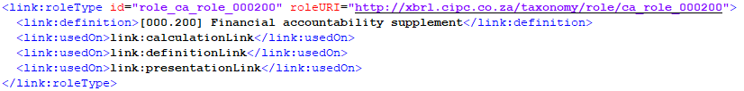
Code example 2: Example of a roleType declaration in the CIPC XBRL Taxonomy

Sets of relations
The CIPC XBRL Taxonomy contains relations in the presentation, definition, calculation and generic linkbases. Relations in the presentation and calculation linkbase should be constructed as defined in the XBRL 2.1 Specification. Definition linkbase relations should be constructed using arcs with arcroles defined in XBRL Dimensions 1.0.
Relations should provide semantic information on:
- placement of concepts (items with dimensional information) in particular information sets (such as Auditor’s report, Statement of financial position, current/non-current, etc.),
- application of dimensional information for items,
- hierarchical structures between items and members of dimensions.
Moreover, for the Primary Financial Statements under IFRS-FULL, IFRS-SMEs, CO-OPs and GRAP modules, each presentation and definition linkbase hierarchy is structured differently from its original IFRS taxonomy representation. In particular, each tree starts with an explanatory text block element (with data nonnum:textBlockItemType) followed by an abstract item under which the contents of particular statement are stored. This is to allow reporting entities (e.g. banks or insurance companies) who may not be in a position to report on actual data elements in the PFSs due to industry-specific positions that are not covered by the CIPC taxonomy, to tag whole statements in a single block of text.
Examples of the above approach are presented on the screen below:

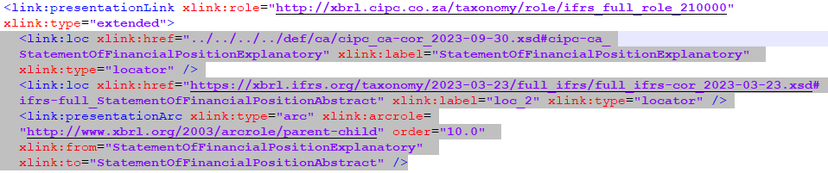

Code example 4: Application of explanatory text block item as a main placeholder for the presentation tree structure

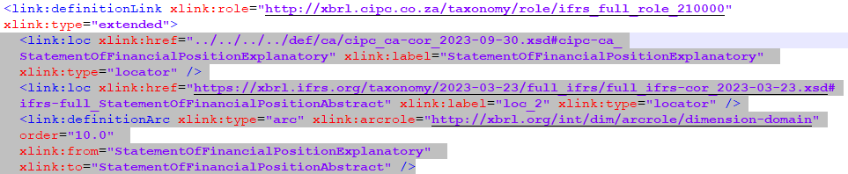
Code example 5: Application of explanatory text block item as a main placeholder for the definition tree structure
Please note that the reporting entities are only required to use the explanatory text block for the PFS reporting only in cases as described in the Filers Guidelines: Business Aspects.

Labels
The CIPC XBRL Taxonomy contains English labels for each concept. Additionally, it should contain also generic labels for other constructs such as roleTypes, however at current there is no such requirement. Apart from CIPC-specific labels introduced for the elements defined in the taxonomy, all IFRS XBRL Taxonomy labels are also stored in the Label Linkbase.
Apart from the standard labels (which role is http://www.xbrl.org/2003/role/label) the CIPC XBRL Taxonomy includes also other labels for certain concepts, including:
- period start (label role http://www.xbrl.org/2003/role/periodStartLabel),
- period end (label role http://www.xbrl.org/2003/role/periodEndLabel),
- net label (label role http://www.xbrl.org/2009/role/netLabel)
- negated label (label role http://www.xbrl.org/2009/role/negatedLabel)
- negated terse label (label role http://www.xbrl.org/2009/role/negatedTerseLabel)
- terse label (label role http://www.xbrl.org/2003/role/terseLabel)
- documentation label (label role http://www.xbrl.org/2003/role/documentation)
- total label (label role http://www.xbrl.org/2003/role/totalLabel)
in order to cover requirements set by the IFRS XBRL Taxonomy. These label roles are referenced from arcs in the presentation linkbase using a standard @preferredLabel attribute (as defined in the XBRL 2.1 Specification).
Code example 5: @preferredLabel attribute code example
Although possible, the CIPC XBRL Taxonomy is not using the Generic preferred labels at the current taxonomy version.

References
In order to facilitate understanding of meaning and content of concepts defined, the CIPC XBRL Taxonomy is providing (where possible) references to legal regulations. These references should be constructed using parts defined by the XBRL International (Appendix B of the Financial Reporting Taxonomy Architecture with errata corrections to 2006-03-20). The parts used by the CIPC XBRL Taxonomy describing only Companies Act specific elements are presented below:
Part | Description
Name | Name refers to the specific publication. For example, “Statement of Financial Standards”, “Statement of Position” or “IFRS”. It does not include the number.
Section | Section is used to capture information typically captured in sections of legislation or reference documents.
Table 2: List of reference parts used in CIPC XBRL Taxonomy
All CIPC-specific references are defined in http://www.xbrl.org/2003/role/reference standard role. XBRL standard provides a number of roles that can be used in order to more precisely indicate the type of reference expressed by parts (e.g. related to measurement, definition, etc.).
CIPC XBRL Taxonomy is also storing IFRS XBRL Taxonomy references to all relevant concepts that are arranged within the CIPC structures. Sample of reference defined in the CIPC XBRL Taxonomy is presented below on the code example:
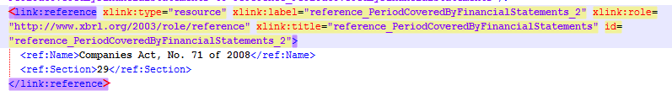
Code example 6: Sample reference linkbase

Application of dimensions
The CIPC XBRL Taxonomy makes use of XBRL dimensions in order to reflect the reporting requirements set by the Companies Act, No. 71 of 2008.
The designated container for dimensional information in instance documents should be scenario element as indicated on definition arcs with http://xbrl.org/int/dim/arcrole/all arcrole. The taxonomy should not contain any arc with http://xbrl.org/int/dim/arcrole/notAll, however this may be subject of change, depending on the future requirements. Every hypercube should be closed (@closed="true").
Please note that not all of the dimensional items available in the CIPC taxonomy are intended for reporting. Due to application of the IFRS taxonomy, all items defined in that taxonomy were imported by the CIPC schema, including dimensional constructs that may not necessarily be of any use as of current. Therefore, only those dimensions that are linked in the CIPC structures (within FAS, IFRS-FULL, IFRS-SMEs, CO-OPs and GRAP modules) should be used in the reporting to the CIPC via available entry points, as listed in the earlier section of this document.

Default members of dimensions
The taxonomy is defining a default member for each explicit dimension. This is important information due to the fact that default members must not be declared in instance documents. In order to facilitate discovery of default members they should all be defined in extended links with @roleURI https://xbrl.cipc.co.za/ taxonomy/role/{component of the framework} followed by the number component.

Solo/consolidated
The CIPC XBRL Taxonomy under IFRS modules is applicable for consolidated reports (which include figures and other information for both, a group and a parent) and solo reports containing data of a single entity. This distinction is modelled using XBRL dimension Consolidated and separate financial statements [axis] that is defined in base IFRS component of the framework. There are no distinct files, extended link roles, whatsoever indicating which information is reportable only on solo and which on consolidated basis. It is the responsibility of reporting entities to provide valid information in this regard in instance documents. A single XBRL instance document can contain solo as well as consolidated data. Moreover, all reportable elements present in the CIPC taxonomy under IFRS modules were dimensionally qualified to be used in the solo/consolidated context as defined in the [999.999] Dimensional qualification for line items extended link.

Components of budget and actual amounts
Similarly as in case of solo/consolidated dimension applied for the IFRS modules, the CIPC envisaged the application of a dimension that can be useful for the purposes of reporting different amounts compared with the planned budgets as per the common reporting practice for GRAP entities. To facilitate the process of reporting such amounts in the GRAP module of the CIPC taxonomy, all reportable elements were dimensionally qualified to be used in this context as defined in the [999.999] Dimensional qualification for line items extended link.

Typed dimensions
Typed dimensions are used for allowing disclosing certain information of a predefined type that needs to be further characterized in order to identify its exact meaning.
In particular, they should be used to identify:
- Directors or prescribed officers, and
- Designated personnel responsible for financial accountability,
Typed domains of all typed dimension are always simple constructs which data type is integer. In an instance document typed domain must be instantiated as a unique “key” value linking facts that have something in common.
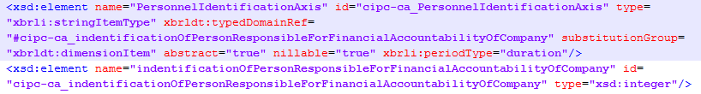
Code example 7: Definition of type dimension and key identifier

Validation rules
Simple validation checks like subtraction or summation are located within the calculation linkbase and deriving from the structures originally modelled by the IFRS XBRL Taxonomy.
Due to limitation of XBRL 2.1 specification more sophisticated rules are covered by Formula 1.0, including supportive modular specifications. Currently CIPC XBRL Taxonomy incorporates set of Value Assertions checking the compliance of the reporting entities with the Minimum Tagging Requirements, as well as a number of logical rules. Additionally, a single Existence Assertion is applied evaluating occurrence of Date of end of reporting period element. Sample formulas defined in the CIPC taxonomy are presented on the code examples 8 and 9.
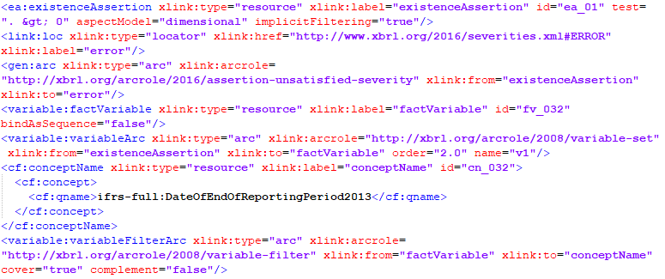
Code example 8: Sample existence assertion defined in the CIPC XBRL Taxonomy
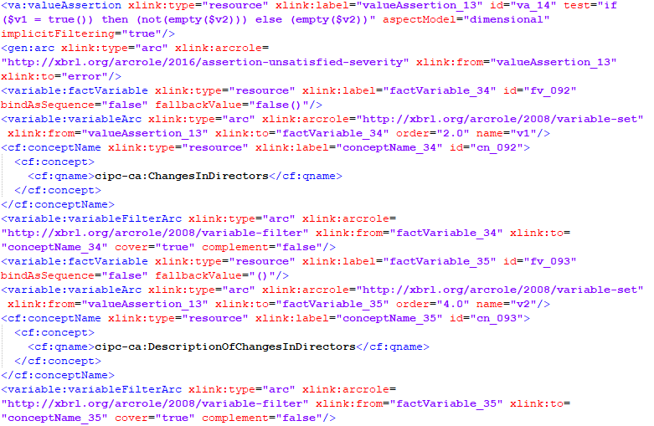
Code example 9: Sample value assertion defined in the CIPC XBRL Taxonomy
To avoid automatic rejection of submitted reports due to formula inconsistencies, some business rules are marked as warnings rather than critical errors. This distinction between warning and error is reflected technically in the taxonomy formula linkbase with use of Assertions Severity 1.0 specification. For each assertion marked as either warning or error there is a generic arc connecting it with a relevant element from the specification schema with use of http://xbrl.org/arcrole/2016/assertion-unsatisfied-severity arcrole.
Please refer below to the code example for details:
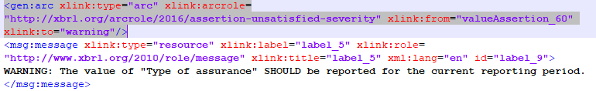
Code example 11: Application of Assertion Severity 1.0 specification
All elements that are not provided with a fact value and will raise warnings during formula evaluation, must be reported with nil attribute set to “true”. For such nil values, a footnote must be attached to the fact. This is validated with a value assertion with id=”va_20”. All footnotes must be provided with xml:lang attribute set to English. The link:footnoteLink element must use xlink:role=”http://www.xbrl.org/2003/role/link” as the standard role and the link:footnote element must use xlink:role=”http://www.xbrl.org/2003/role/footnote” as the standard role. The link:footnoteArc must only use the xlink:arcrole=”http://www.xbrl.org/2003/arcrole/fact-footnote” as the standard arcrole.
In addition, for four elements from the mandatory list marked as warnings (Liabilities, Third party liabilities and Turnover, Revenue), there is a value assertion that requires for all those facts with value set to ‘0’ to provide explanatory footnotes. Same conditions apply as described it the above paragraph.
Each formula defined in the CIPC XBRL taxonomy provides a human readable error description in English. Errors are defined according to the Generic Messages 1.0. specification. Sample of generic message is provided in the code example below.
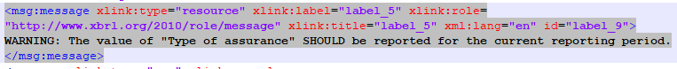
Code example 10: Sample of error message defined in the CIPC XBRL Taxonomy
CIPC XBRL Taxonomy defines 1 existence and 79 value assertions (attached selectively for particular entry points) of which 20 are logical rules and 59 are existence checks (only 50 applicable to IFRS-FULL and IFRS-SMEs modules). Formulas defined in the CIPC XBRL Taxonomy are summarized in the below table:

Formula purpose | Count | Pattern applied
Existence assertion – used for evaluating occurrence of particular element defined in the taxonomy. Applied as Formula 1.0. existenceAssertion element. | 1 | ea_{subsequent number}
Existence check – used for checking the compliance with the Minimum Tagging Requirements. Elements must be reported in the instance document for the current reporting period. Applied as Formula 1.0. valueAssertion element. | 59 | ec_{subsequent number}
Logical check – used for checking various logical rules (e.g. if-then-else conditional expressions). Applied as Formula 1.0. valueAssertion element. | 20 | va_{subsequent number}
Table 3: Summary of formulas defined in the CIPC XBRL Taxonomy
List of all formulas is provided in the Appendix A: List of business rules and compliance checks.

Relation to other taxonomies
The CIPC XBRL Taxonomy is considered as extension of the IFRS XBRL Taxonomy dated March 23th, 2023, therefore it follows most of its architectural guidelines and modelling approaches, as prescribed by the IFRS Taxonomy Guide 2023.
Nevertheless the CIPC XBRL taxonomy framework contains also a number of departures from the rules set out by the IFRS taxonomy architecture. This results from specific requirements not addressed by the IFRS taxonomy (e.g. extensive use of typed dimensions).

Versioning
CIPC XBRL Taxonomy version is indicated using a Taxonomy Package META-INF container (as described in the section below), publication date on file names as well as on the folder name following the root location of the taxonomy set.

Taxonomy Package
CIPC XBRL Taxonomy is provided as a .zip archive, created accordingly to the Taxonomy Packages 1.0 specification (Recommendation as published on 2016-04-19). CIPC XBRL Taxonomy Set contents are defined under the META-INF container within the root folder of the taxonomy, which includes the following configuration files:
- catalog.xml that provides URL remapping to the taxonomy folder stored locally
- taxonomyPackage.xml that provides general information about the taxonomy identification, versioning, publisher and available entry points.
Purpose of the above is to provide the users of the CIPC XBRL Taxonomy with a convenient way of accessing the taxonomy and browsing through its contents. The CIPC XBRL Taxonomy Package is available under the official web location of the Companies and Intellectual Properties Commission.
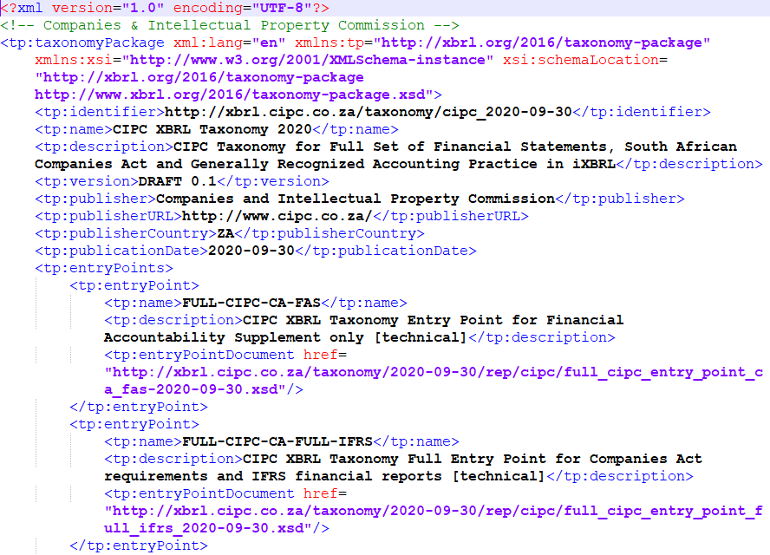
Code example 11: CIPC XBRL Taxonomy Package

Enquiries
Any enquiries regarding the taxonomy, its architecture or application should be submitted to the following e-mail: XBRL@cipc.co.za

Appendix A: List of business rules and compliance checks

A.1. List of logical rules applicable for the CA_FAS

ID | Formula expression
va_01 | if (count(Name of reporting entity or other means of identification) > 0) then (if (Manual maintenance of financial records (paper based) = true()) then (Electronic maintenance of financial records (computer based) = false()) else (Electronic maintenance of financial records (computer based) = true())) else (false())
Table 4: List of logical rules applicable for the CA_FAS

A.2. Minimum Tagging Requirements applicable for the CA_FAS

ID | Mandatory element | Formula expression
ea_01 | Date of end of reporting period | . > 0
ec_03 | Registration number of company | if (empty(Registration number of company)) then false() else (xs:date(xfi:period-end(xfi:period(Registration number of company))) eq (xs:date(Date of end of reporting period) + xs:dayTimeDuration('P1D'))) [dimensional]
ec_04 | Name of designated person responsible for financial accountability of company | if (empty(Name of designated person responsible for financial accountability of company)) then false() else (xs:date(xfi:period-end(xfi:period(Name of designated person responsible for financial accountability of company))) eq (xs:date(Date of end of reporting period) + xs:dayTimeDuration('P1D')))
ec_05 | Telephone number of designated person responsible for financial accountability of company | if (empty(Name of designated person responsible for financial accountability of company)) then (false()) else (if (empty(Telephone number of designated person responsible for financial accountability of company)) then false() else (xs:date(xfi:period-end(xfi:period(Telephone number of designated person responsible for financial accountability of company))) eq (xs:date(Date of end of reporting period) + xs:dayTimeDuration('P1D'))))
ec_06 | Responsibility for recording day to day financial transactions and maintaining company's financial records | if (empty(Name of designated person responsible for financial accountability of company)) then (false()) else (if (empty(Responsibility for recording day to day financial transactions and maintaining company's financial records)) then false() else (xs:date(xfi:period-end(xfi:period(Responsibility for recording day to day financial transactions and maintaining company's financial records))) eq (xs:date(Date of end of reporting period) + xs:dayTimeDuration('P1D'))))
ec_07 | Responsibility for compiling financial information and preparing reports or statements | if (empty(Name of designated person responsible for financial accountability of company)) then (false()) else (if (empty(Responsibility for compiling financial information and preparing reports or statements )) then false() else (xs:date(xfi:period-end(xfi:period(Responsibility for compiling financial information and preparing reports or statements ))) eq (xs:date(Date of end of reporting period) + xs:dayTimeDuration('P1D'))))
ec_08 | Responsibility for providing advice to company concerning maintenance of financial records | if (empty(Name of designated person responsible for financial accountability of company)) then (false()) else (if (empty(Responsibility for providing advice to company concerning maintenance of financial records)) then false() else (xs:date(xfi:period-end(xfi:period(Responsibility for providing advice to company concerning maintenance of financial records))) eq (xs:date(Date of end of reporting period) + xs:dayTimeDuration('P1D'))))
ec_09 | Responsibility for performing Independent review of Annual Financial Statements | if (empty(Name of designated person responsible for financial accountability of company)) then (false()) else (if (empty(Responsibility for performing Independent review of Annual Financial Statements)) then false() else (xs:date(xfi:period-end(xfi:period(Responsibility for performing Independent review of Annual Financial Statements))) eq (xs:date(Date of end of reporting period) + xs:dayTimeDuration('P1D'))))
ec_10 | Recognised profession of designated person performing Independent review of Annual Financial Statements | if (empty(Name of designated person responsible for financial accountability of company)) then (false()) else (if (empty(Recognised profession of designated person performing Independent review of Annual Financial Statements)) then false() else (xs:date(xfi:period-end(xfi:period(Recognised profession of designated person performing Independent review of Annual Financial Statements))) eq (xs:date(Date of end of reporting period) + xs:dayTimeDuration('P1D'))))
ec_11 | Practice number of designated person performing Independent review of Annual Financial Statements | if (empty(Name of designated person responsible for financial accountability of company)) then (false()) else (if (empty(Practice number of designated person performing Independent review of Annual Financial Statements)) then false() else (xs:date(xfi:period-end(xfi:period(Practice number of designated person performing Independent review of Annual Financial Statements))) eq (xs:date(Date of end of reporting period) + xs:dayTimeDuration('P1D'))))
Table 5: Minimum Tagging Requirements applicable for the CA_FAS

A.3. List of logical rules selectively applicable for the IFRS, CO-OP and GRAP modules

ID | Formula expression
va_01 | if (Annual Financial Statements audited = false()) then (empty(Date of audit of Annual Financial Statements)) else (if (Annual Financial Statements audited = true()) then (not(empty(Date of audit of Annual Financial Statements))) else false())
va_02 | if (Resident of South Africa = false()) then (if (not(empty(Country of origin of designated person responsible for compliance))) then (if (not(empty(Passport number of designated person responsible for compliance))) then (not(empty(Date of birth of designated person responsible for compliance))) else (false())) else (false())) else (if (Resident of South Africa = true()) then (not(empty(Identity number of designated person responsible for compliance))) else (false()))
va_03 | if (count(Full registered name of company) > 0) then (if (Annual Financial Statements audited = true()) then (if (Annual Financial Statements internally compiled = false()) then (Annual Financial Statements independently compiled and reported on = false()) else (false())) else (if (Annual Financial Statements audited = false()) then (if (Annual Financial Statements internally compiled = true()) then (Annual Financial Statements independently compiled and reported on = false()) else (if (Annual Financial Statements internally compiled = false()) then (Annual Financial Statements independently compiled and reported on = true()) else (false()))) else (false()))) else (false())
va_04 | if (Annual Financial Statements independently compiled and reported on = false()) then (empty(Date of independent review of Annual Financial Statement)) else (not(empty(Date of independent review of Annual Financial Statement)))
va_05 | if (Public interest score >= 350) then ( Annual Financial Statements audited = true()) else (Public interest score >= 0)
va_06 | if (Annual Financial Statements audited = true()) then (not(empty(Name of auditor))) else (true())
va_08 | if ((Public interest score >= 500) or (Type of company = 'https://xbrl.cipc.co.za/taxonomy/ca/enum#DomesticStateOwnedCompany')) then (not(empty(Disclosure of social and ethics committee [text block]))) else (Public interest score >= 0) [dimensional]
va_09 | if (not(empty(Name of director or prescribed officer))) then (not(empty(Director's remuneration))) else (empty(Director's remuneration))
va_10 | if (Solvency and Liquidity tests satisfied = true()) then ((Financial assistance for subscription of securities != 'https://xbrl.cipc.co.za/taxonomy/ca/enum#NotApplicable') or (Loans granted or other financial assistance to directors != 'https://xbrl.cipc.co.za/taxonomy/ca/enum#NotApplicable') or (Distributions to shareholders authorised by board != 'https://xbrl.cipc.co.za/taxonomy/ca/enum#NotApplicable') or (Capitalization of shares != 'https://xbrl.cipc.co.za/taxonomy/ca/enum#NotApplicable') or (Company or subsidiary acquiring company's shares != 'https://xbrl.cipc.co.za/taxonomy/ca/enum#NotApplicable') or (Amalgamations or Mergers != 'https://xbrl.cipc.co.za/taxonomy/ca/enum#NotApplicable') or (Transfer by company of money or other property other than own shares != 'https://xbrl.cipc.co.za/taxonomy/ca/enum#NotApplicable') or (Other reason != 'https://xbrl.cipc.co.za/taxonomy/ca/enum#NotApplicable')) else (true()) [dimensional]
va_11 | if (Other reason = 'https://xbrl.cipc.co.za/taxonomy/ca/enum#NotApplicable') then (empty(Description of other reason)) else (not(empty(Description of other reason))) [dimensional]
va_12 | if (Changes in registered office = true()) then (not(empty(Description of changes in registered office))) else (empty(Description of changes in registered office))
va_13 | if (Changes in location of records = true()) then (not(empty(Description of changes in location of records))) else (empty(Description of changes in location of records))
va_14 | if (Changes in directors = true()) then (not(empty(Description of changes in directors))) else (empty(Description of changes in directors)) [dimensional]
va_15 | if (Changes in company secretary = true()) then (not(empty(Description of changes in company secretary))) else (empty(Description of changes in company secretary))
va_16 | if (Changes in auditors and audit committees = true()) then (not(empty(Description of changes in auditors and audit committees))) else (empty(Description of changes in auditors and audit committees))
va_17 | if (Changes in financial year end = true()) then (not(empty(Description of changes in financial year end))) else (empty(Description of changes in financial year end))
va_18 | if (Annual Financial Statements independently compiled and reported on = true()) then (not(empty(Name of independent reviewer))) else (true())
va_19 | Public interest score = Average number of employees + fn:round(Third party liabilities div 100000) + fn:round(Turnover div 100000) + Maximum number of individuals with beneficial interest in securities of company, or members in case of non profit company [dimensional]
va_20 | count(xfi:fact-footnotes($v1, '', '', '', 'en')) gt 0
va_21 | count(xfi:fact-footnotes($v1, '', '', '', 'en')) gt 0
va_22 | if (Annual Financial Statements audited = true()) then (not(empty(Name of auditor)) and not(empty(Practice number of auditor))) else (true())
va_23 | if (ends-with(Registration number of company, '/06') or ends-with(Registration number of company, '/30')) then (not(empty(Disclosure of company secretary's statement [text block]))) else (true())
va_24 | if (Declaration of director's report presence = true()) then (not(empty(Disclosure of directors' report [text block]))) else (true())
va_25 | if (Type of assurance = 'https://xbrl.cipc.co.za/taxonomy/ca/enum#Audited') then (not(empty(Disclosure of auditor's opinion [text block]))) else (true())
va_26 | if (Type of assurance = 'https://xbrl.cipc.co.za/taxonomy/ca/enum#Audited') then (not(empty(Name of auditor))) else (true())
va_27 | if (Type of assurance = 'https://xbrl.cipc.co.za/taxonomy/ca/enum#Audited') then (not(empty(Practice number of auditor))) else (true())
va_28 | if (Type of assurance = 'https://xbrl.cipc.co.za/taxonomy/ca/enum#Audited') then (not(empty(Name of auditing company))) else (true())
va_29 | if (Type of assurance = 'https://xbrl.cipc.co.za/taxonomy/ca/enum#Audited') then (not(empty(Type of auditors' opinion))) else (true())
va_30 | if (Type of assurance = 'https://xbrl.cipc.co.za/taxonomy/ca/enum#Audited') then (not(empty(Disclosure of directors' remuneration [text block]))) else (true())
va_31 | if (Type of assurance = 'https://xbrl.cipc.co.za/taxonomy/ca/enum#Audited') then (not(empty(Director's remuneration))) else (true())
va_32 | if (Type of assurance = 'https://xbrl.cipc.co.za/taxonomy/ca/enum#Audited') then (not(empty(Disclosure of auditor's report [text block]))) else (true())
va_33 | if (Type of company = 'https://xbrl.cipc.co.za/taxonomy/ca/enum#DomesticPublicListedCompany') then (not(empty(Earnings per share [text block]))) else (true())
va_34 | if (Type of company = 'https://xbrl.cipc.co.za/taxonomy/ca/enum#DomesticPublicListedCompany') then (not(empty(Basic earnings (loss) per share))) else (true())
va_35 | if (Type of company = 'https://xbrl.cipc.co.za/taxonomy/ca/enum#DomesticPublicListedCompany') then (not(empty(Diluted earnings (loss) per share))) else (true())
va_36 | if (ends-with(Registration number of company, '/06') and (Type of company = 'https://xbrl.cipc.co.za/taxonomy/ca/enum#DomesticPublicListedCompany')) then (not(empty(Disclosure of audit committees [text block]))) else (true())
va_37 | if (ends-with(Registration number of company, '/06') and (Type of company = 'https://xbrl.cipc.co.za/taxonomy/ca/enum#DomesticPublicListedCompany')) then (not(empty(Disclosure of social and ethics committee [text block]))) else (true())
va_38 | if (Description of nature of financial statements = 'https://xbrl.cipc.co.za/taxonomy/ca/enum#AuditedConsolidatedAnnualFinancialStatements') then (not(empty(Equity attributable to owners of parent))) else (true()) [dimensional]
va_39 | if (Description of nature of financial statements = 'https://xbrl.cipc.co.za/taxonomy/ca/enum#AuditedConsolidatedAnnualFinancialStatements') then (not(empty(Non-controlling interests))) else (true()) [dimensional]
va_40 | if (Description of nature of financial statements = 'https://xbrl.cipc.co.za/taxonomy/ca/enum#AuditedConsolidatedAnnualFinancialStatements') then (not(empty(Profit (loss), attributable to owners of parent))) else (true()) [dimensional]
va_41 | if (Description of nature of financial statements = 'https://xbrl.cipc.co.za/taxonomy/ca/enum#AuditedConsolidatedAnnualFinancialStatements') then (not(empty(Profit (loss), attributable to non-controlling interests))) else (true()) [dimensional]
va_42 | if (Declaration of auditor's report presence = true()) then (not(empty(Disclosure of auditor's report [text block]))) else (true()) [dimensional]
Table 6: List of logical rules selectively applicable for the IFRS-FULL, IFRS-SMES, CO-OPs and GRAP

A.4. Minimum Tagging Requirements selectively applicable for the IFRS, CO-OP and GRAP

ID | Mandatory element | Formula expression
ea_01 | Date of end of reporting period | . > 0
ec_01 | Turnover | if (empty(Turnover)) then false() else (xs:date(xfi:period-end(xfi:period(Turnover))) eq (xs:date(Date of end of reporting period) + xs:dayTimeDuration('P1D')))
ec_02 | Revenue | if (empty(Revenue)) then false() else (xs:date(xfi:period-end(xfi:period(Revenue))) eq (xs:date(Date of end of reporting period) + xs:dayTimeDuration('P1D')))
ec_03 | Increase (decrease) in equity | if (empty(Increase (decrease) in equity)) then false() else (xs:date(xfi:period-end(xfi:period(Increase (decrease) in equity))) eq (xs:date(Date of end of reporting period) + xs:dayTimeDuration('P1D')))
ec_04 | Cash and cash equivalents | if (empty(Cash and cash equivalents)) then false() else (xs:date(xfi:period-end(xfi:period(Cash and cash equivalents))) eq (xs:date(Date of end of reporting period) + xs:dayTimeDuration('P1D')))
ec_05 | Increase (decrease) in cash and cash equivalents | if (empty(Increase (decrease) in cash and cash equivalents)) then false() else (xs:date(xfi:period-end(xfi:period(Increase (decrease) in cash and cash equivalents))) eq (xs:date(Date of end of reporting period) + xs:dayTimeDuration('P1D')))
ec_06 | Cash flows from (used in) financing activities | if (empty(Cash flows from (used in) financing activities)) then false() else (xs:date(xfi:period-end(xfi:period(Cash flows from (used in) financing activities))) eq (xs:date(Date of end of reporting period) + xs:dayTimeDuration('P1D')))
ec_07 | Cash flows from (used in) investing activities | if (empty(Cash flows from (used in) investing activities)) then false() else (xs:date(xfi:period-end(xfi:period(Cash flows from (used in) investing activities))) eq (xs:date(Date of end of reporting period) + xs:dayTimeDuration('P1D')))
ec_08 | Cash flows from (used in) operating activities | if (empty(Cash flows from (used in) operating activities)) then false() else (xs:date(xfi:period-end(xfi:period(Cash flows from (used in) operating activities))) eq (xs:date(Date of end of reporting period) + xs:dayTimeDuration('P1D')))
ec_09 | Comprehensive income | if (empty(Comprehensive income)) then false() else (xs:date(xfi:period-end(xfi:period(Comprehensive income))) eq (xs:date(Date of end of reporting period) + xs:dayTimeDuration('P1D')))
ec_10 | Other comprehensive income | if (empty(Other comprehensive income)) then false() else (xs:date(xfi:period-end(xfi:period(Other comprehensive income))) eq (xs:date(Date of end of reporting period) + xs:dayTimeDuration('P1D')))
ec_11 | Tax expense (income), continuing operations | if (empty(Tax expense (income))) then false() else (xs:date(xfi:period-end(xfi:period(Tax expense (income)))) eq (xs:date(Date of end of reporting period) + xs:dayTimeDuration('P1D')))
ec_12 | Profit (loss) | if (empty(Profit (loss))) then false() else (xs:date(xfi:period-end(xfi:period(Profit (loss)))) eq (xs:date(Date of end of reporting period) + xs:dayTimeDuration('P1D')))
ec_13 | Profit (loss) before tax | if (empty(Profit (loss) before tax)) then false() else (xs:date(xfi:period-end(xfi:period(Profit (loss) before tax))) eq (xs:date(Date of end of reporting period) + xs:dayTimeDuration('P1D')))
ec_14 | Assets | if (empty(Assets)) then false() else (xs:date(xfi:period-end(xfi:period(Assets))) eq (xs:date(Date of end of reporting period) + xs:dayTimeDuration('P1D')))
ec_15 | Equity | if (empty(Equity)) then false() else (xs:date(xfi:period-end(xfi:period(Equity))) eq (xs:date(Date of end of reporting period) + xs:dayTimeDuration('P1D')))
ec_16 | Equity and liabilities | if (empty(Equity and liabilities)) then false() else (xs:date(xfi:period-end(xfi:period(Equity and liabilities))) eq (xs:date(Date of end of reporting period) + xs:dayTimeDuration('P1D')))
ec_17 | Disclosure of directors' responsibility [text block] | if (empty(Disclosure of directors' responsibility [text block])) then false() else (xs:date(xfi:period-end(xfi:period(Disclosure of directors' responsibility [text block]))) eq (xs:date(Date of end of reporting period) + xs:dayTimeDuration('P1D')))
ec_18 | Date of approval of annual financial statements | if (empty(Date of approval of annual financial statements)) then false() else (xs:date(xfi:period-end(xfi:period(Date of approval of annual financial statements))) eq (xs:date(Date of end of reporting period) + xs:dayTimeDuration('P1D')))
ec_19 | Disclosure of directors' report [text block] | if (empty(Disclosure of directors' report [text block])) then false() else (xs:date(xfi:period-end(xfi:period(Disclosure of directors' report [text block]))) eq (xs:date(Date of end of reporting period) + xs:dayTimeDuration('P1D')))
ec_20 | Date of publication of financial statements | if (empty(Date of publication of financial statements)) then false() else (xs:date(xfi:period-end(xfi:period(Date of publication of financial statements))) eq (xs:date(Date of end of reporting period) + xs:dayTimeDuration('P1D')))
ec_21 | Declaration of signature by authorised director | if (empty(Declaration of signature by authorised director)) then false() else (xs:date(xfi:period-end(xfi:period(Declaration of signature by authorised director))) eq (xs:date(Date of end of reporting period) + xs:dayTimeDuration('P1D')))
ec_22 | Software name | if (empty(Software name)) then false() else (xs:date(xfi:period-end(xfi:period(Software name))) eq (xs:date(Date of end of reporting period) + xs:dayTimeDuration('P1D')))
ec_23 | Declaration of director's report presence | if (empty(Declaration of director's report presence)) then false() else (xs:date(xfi:period-end(xfi:period(Declaration of director's report presence))) eq (xs:date(Date of end of reporting period) + xs:dayTimeDuration('P1D')))
ec_24 | Declaration of auditor's report presence | if (empty(Declaration of auditor's report presence)) then false() else (xs:date(xfi:period-end(xfi:period(Declaration of auditor's report presence))) eq (xs:date(Date of end of reporting period) + xs:dayTimeDuration('P1D')))
ec_25 | Professional designation of individual responsible for preparation or supervising preparation of financial statements | if (empty(Professional designation of individual responsible for preparation or supervising preparation of financial statements)) then false() else (xs:date(xfi:period-end(xfi:period(Professional designation of individual responsible for preparation or supervising preparation of financial statements))) eq (xs:date(Date of end of reporting period) + xs:dayTimeDuration('P1D')))
ec_26 | Name of individual responsible for preparation or supervising preparation of financial statements | if (empty(Name of individual responsible for preparation or supervising preparation of financial statements)) then false() else (xs:date(xfi:period-end(xfi:period(Name of individual responsible for preparation or supervising preparation of financial statements))) eq (xs:date(Date of end of reporting period) + xs:dayTimeDuration('P1D')))
ec_27 | Software version | if (empty(Software version)) then false() else (xs:date(xfi:period-end(xfi:period(Software version))) eq (xs:date(Date of end of reporting period) + xs:dayTimeDuration('P1D')))
ec_28 | Type of assurance | if (empty(Type of assurance)) then false() else (xs:date(xfi:period-end(xfi:period(Type of assurance))) eq (xs:date(Date of end of reporting period) + xs:dayTimeDuration('P1D')))
ec_29 | Level of rounding used in financial statements | if (empty(Level of rounding used in financial statements)) then false() else (xs:date(xfi:period-end(xfi:period(Level of rounding used in financial statements))) eq (xs:date(Date of end of reporting period) + xs:dayTimeDuration('P1D')))
ec_30 | Description of presentation currency | if (empty(Description of presentation currency)) then false() else (xs:date(xfi:period-end(xfi:period(Description of presentation currency))) eq (xs:date(Date of end of reporting period) + xs:dayTimeDuration('P1D')))
ec_31 | Period covered by financial statements | if (empty(Period covered by financial statements)) then false() else (xs:date(xfi:period-end(xfi:period(Period covered by financial statements))) eq (xs:date(Date of end of reporting period) + xs:dayTimeDuration('P1D')))
ec_32 | Description of nature of financial statements | if (empty(Description of nature of financial statements)) then false() else (xs:date(xfi:period-end(xfi:period(Description of nature of financial statements))) eq (xs:date(Date of end of reporting period) + xs:dayTimeDuration('P1D')))
ec_33 | Postal address same as business address | if (empty(Postal address same as business address)) then false() else (xs:date(xfi:period-end(xfi:period(Postal address same as business address))) eq (xs:date(Date of end of reporting period) + xs:dayTimeDuration('P1D')))
ec_34 | Business address, country | if (empty(Business address, country)) then false() else (xs:date(xfi:period-end(xfi:period(Business address, country))) eq (xs:date(Date of end of reporting period) + xs:dayTimeDuration('P1D')))
ec_35 | Business address, city | if (empty(Business address, city)) then false() else (xs:date(xfi:period-end(xfi:period(Business address, city))) eq (xs:date(Date of end of reporting period) + xs:dayTimeDuration('P1D')))
ec_36 | Business address, postal code | if (empty(Business address, postal code)) then false() else (xs:date(xfi:period-end(xfi:period(Business address, postal code))) eq (xs:date(Date of end of reporting period) + xs:dayTimeDuration('P1D')))
ec_37 | Business address, street name | if (empty(Business address, street name)) then false() else (xs:date(xfi:period-end(xfi:period(Business address, street name))) eq (xs:date(Date of end of reporting period) + xs:dayTimeDuration('P1D')))
ec_38 | Type of company | if (empty(Type of company)) then false() else (xs:date(xfi:period-end(xfi:period(Type of company))) eq (xs:date(Date of end of reporting period) + xs:dayTimeDuration('P1D')))
ec_39 | Full registered name of company | if (empty(Full registered name of company)) then false() else (xs:date(xfi:period-end(xfi:period(Full registered name of company))) eq (xs:date(Date of end of reporting period) + xs:dayTimeDuration('P1D')))
ec_40 | Annual financial statements audited | if (empty(Annual financial statements audited)) then false() else (xs:date(xfi:period-end(xfi:period(Annual financial statements audited))) eq (xs:date(Date of end of reporting period) + xs:dayTimeDuration('P1D')))
ec_41 | Annual financial statements independently compiled and reported on | if (empty(Annual financial statements independently compiled and reported on)) then false() else (xs:date(xfi:period-end(xfi:period(Annual financial statements independently compiled and reported on))) eq (xs:date(Date of end of reporting period) + xs:dayTimeDuration('P1D')))
ec_48 | Principal place of business | if (empty(Principal place of business)) then false() else (xs:date(xfi:period-end(xfi:period(Principal place of business))) eq (xs:date(Date of end of reporting period) + xs:dayTimeDuration('P1D')))
ec_49 | Description of nature of entity's operations and principal activities | if (empty(Description of nature of entity's operations and principal activities)) then false() else (xs:date(xfi:period-end(xfi:period(Description of nature of entity's operations and principal activities))) eq (xs:date(Date of end of reporting period) + xs:dayTimeDuration('P1D')))
ec_50 | Email address of company | if (empty(Email address of company)) then false() else (xs:date(xfi:period-end(xfi:period(Email address of company))) eq (xs:date(Date of end of reporting period) + xs:dayTimeDuration('P1D')))
ec_51 | Third party liabilities | if (empty(Third party liabilities)) then false() else (xs:date(xfi:period-end(xfi:period(Third party liabilities))) eq (xs:date(Date of end of reporting period) + xs:dayTimeDuration('P1D')))
ec_52 | Liabilities | if (empty(Liabilities)) then false() else (xs:date(xfi:period-end(xfi:period(Liabilities))) eq (xs:date(Date of end of reporting period) + xs:dayTimeDuration('P1D')))
ec_53 | Maximum number of individuals with beneficial interest in securities of company, or members in case of non profit company | if (empty(Maximum number of individuals with beneficial interest in securities of company, or members in case of non profit company)) then false() else (xs:date(xfi:period-end(xfi:period(Maximum number of individuals with beneficial interest in securities of company, or members in case of non profit company))) eq (xs:date(Date of end of reporting period) + xs:dayTimeDuration('P1D')))
ec_54 | Average number of employees | if (empty(Average number of employees)) then false() else (xs:date(xfi:period-end(xfi:period(Average number of employees))) eq (xs:date(Date of end of reporting period) + xs:dayTimeDuration('P1D')))
ec_55 | Registration number of company | if (empty(Registration number of company)) then false() else (xs:date(xfi:period-end(xfi:period(Registration number of company))) eq (xs:date(Date of end of reporting period) + xs:dayTimeDuration('P1D')))
ec_56 | Name of designated person responsible for compliance | if (empty(Name of designated person responsible for compliance)) then false() else (xs:date(xfi:period-end(xfi:period(Name of designated person responsible for compliance))) eq (xs:date(Date of end of reporting period) + xs:dayTimeDuration('P1D')))
ec_57 | Public interest score | if (empty(Public interest score)) then false() else (xs:date(xfi:period-end(xfi:period(Public interest score))) eq (xs:date(Date of end of reporting period) + xs:dayTimeDuration('P1D')))
ec_60 | Customer code | if (empty(Customer code)) then false() else (xs:date(xfi:period-end(xfi:period(Customer code))) eq (xs:date(Date of end of reporting period) + xs:dayTimeDuration('P1D')))
ec_61 | Issued capital | if (empty(Issued capital)) then false() else (xs:date(xfi:period-end(xfi:period(Issued capital))) eq (xs:date(Date of end of reporting period) + xs:dayTimeDuration('P1D')))
ec_62 | Retained earnings | if (empty(Retained earnings)) then false() else (xs:date(xfi:period-end(xfi:period(Retained earnings))) eq (xs:date(Date of end of reporting period) + xs:dayTimeDuration('P1D')))
ec_63 | Current assets | if (empty(Current assets)) then false() else (xs:date(xfi:period-end(xfi:period(Current assets))) eq (xs:date(Date of end of reporting period) + xs:dayTimeDuration('P1D')))
ec_64 | Name of director authorised to approve annual financial statements | if (empty(Name of director authorised to approve annual financial statements)) then false() else (xs:date(xfi:period-end(xfi:period(Name of director authorised to approve annual financial statements))) eq (xs:date(Date of end of reporting period) + xs:dayTimeDuration('P1D')))
ec_65 | Disclosure of directors [text block])) | if (empty(Disclosure of directors [text block])) then false() else (xs:date(xfi:period-end(xfi:period(Disclosure of directors [text block]))) eq (xs:date(Date of end of reporting period) + xs:dayTimeDuration('P1D')))
ec_66 | Current liabilities | if (empty(Current liabilities)) then false() else (xs:date(xfi:period-end(xfi:period(Current liabilities))) eq (xs:date(Date of end of reporting period) + xs:dayTimeDuration('P1D')))
ec_67 | Administrative expenses | if (empty(Administrative expenses)) then false() else (xs:date(xfi:period-end(xfi:period(Administrative expenses))) eq (xs:date(Date of end of reporting period) + xs:dayTimeDuration('P1D')))
ec_68 | Equity | if (empty(Equity)) then false() else (xs:date(xfi:period-end(xfi:period(Equity))) eq (xs:date(Date of end of reporting period) + xs:dayTimeDuration('P1D')))
ec_69 | Disclosure of material accounting policy information [text block] | if (empty(Disclosure of material accounting policy information [text block])) then false() else (xs:date(xfi:period-end(xfi:period(Disclosure of material accounting policy information [text block]))) eq (xs:date(Date of end of reporting period) + xs:dayTimeDuration('P1D')))
ec_70 | Disclosure of holding company and ultimate holding company [text block] | if (empty(Disclosure of holding company and ultimate holding company [text block])) then false() else (xs:date(xfi:period-end(xfi:period(Disclosure of holding company and ultimate holding company [text block]))) eq (xs:date(Date of end of reporting period) + xs:dayTimeDuration('P1D')))
Table 7: Minimum Tagging Requirements selectively applicable for the IFRS-FULL, IFRS-SMES, CO-OPs and GRAP
All other assertions will be treated as errors, therefore if not evaluated correctly may cause rejection of the submitted report. For most up to date list of mandatory elements, please refer to the CIPC website.

As available on http://specifications.xbrl.org/
As defined in http://www.xbrl.org/technical/guidance/FRTA-RECOMMENDATION-2005-04-25+corrected-errata-2006-03-20.htm (FRTA) rule 2.1.5. This pattern applies to items, abstracts, dimensional constructs, roleTypes, data types and enumerations for custom data types.
See: https://cdn.ifrs.org/-/media/feature/standards/taxonomy/general-resources/ifrs-taxonomy-architecture/ifrs_taxonomy_architecture_2020.pdf
This is for the reasons that it is always possible to indicate a moment in time using two identical dates (more precisely data and time) while it is not possible to describe a period of time using just a single date. The same approach was taken by the IFRS taxonomy.
As defined in http://www.xbrl.org/2003/xbrl-instance-2003-12-31.xsd
As defined in https://www.xbrl.org/dtr/type/2020-01-21/types.xsd
As defined in https://www.xbrl.org/2020/extensible-enumerations-2.0.xsd
As defined in http://www.xbrl.org/2005/xbrldt-2005.xsd
As defined in http://www.xbrl.org/dtr/type/nonNumeric-2009-12-16.xsd
http://en.wikipedia.org/wiki/Uniform_Resource_Identifier
See http://www.cipc.co.za/files/8615/1178/8671/07082017_Guidelines_for_Filing__AFSs_in_XBRL_by_Client_Companies_v1-2_Business_Aspects_HV.pdf
http://www.xbrl.org/Specification/XBRL-RECOMMENDATION-2003-12-31+Corrected-Errata-2008-07-02.htm#_5.2.2.2
http://www.xbrl.org/Specification/XBRL-RECOMMENDATION-2003-12-31+Corrected-Errata-2008-07-02.htm#_5.2.4.2
http://www.xbrl.org/technical/guidance/FRTA-RECOMMENDATION-2005-04-25+corrected-errata-2006-03-20.htm#_Toc131223668
http://www.xbrl.org/Specification/XBRL-RECOMMENDATION-2003-12-31+Corrected-Errata-2008-07-02.htm#_5.2.3.2
http://www.xbrl.org/Specification/XDT-REC-2006-09-18+Corrected-Errata-2009-09-07.htm
http://www.xbrl.org/Specification/XDT-REC-2006-09-18+Corrected-Errata-2009-09-07.htm#_Toc243301768
http://specifications.xbrl.org/work-product-index-formula-formula-1.0.html
See http://www.xbrl.org/Specification/assertion-severity/REC-2016-04-19/assertion-severity-REC-2016-04-19.html
https://www.xbrl.org/Specification/taxonomy-package/REC-2016-04-19/taxonomy-package-REC-2016-04-19.html

